MOP Node8, Node 9, Node 10, Node 11 扩容

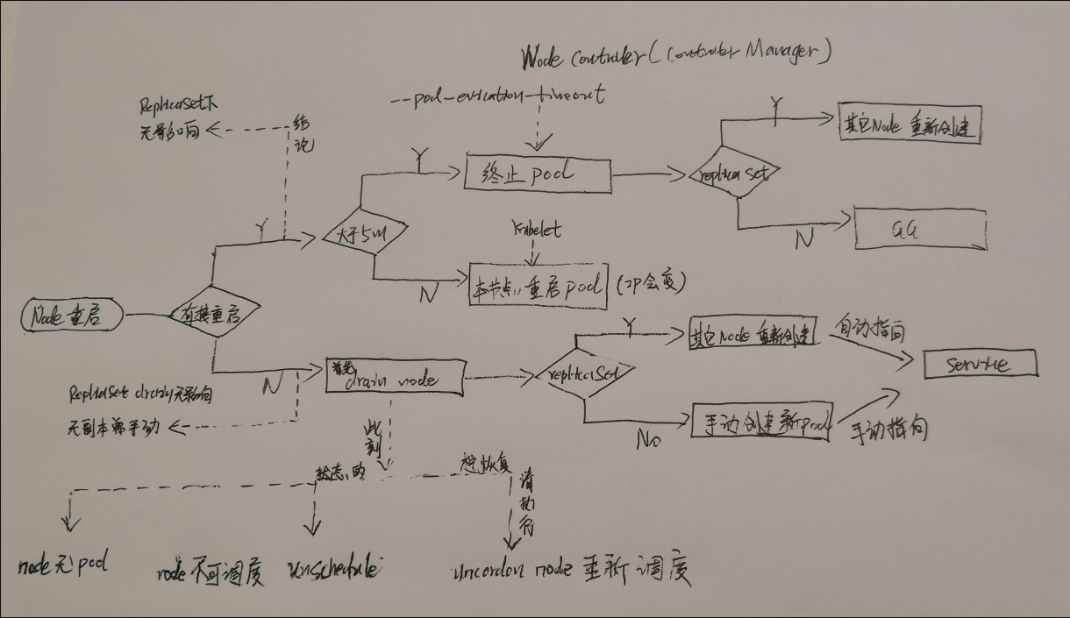

1. 扩容原因：

Node8, Node 9, Node 10, Node 11 CPU使用率均超过80%，部分超过100%

2/32 🡺 4/32

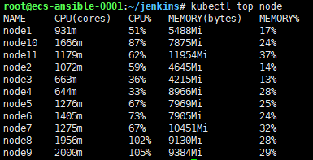

1. IP 情况

|  |  |  |
| --- | --- | --- |
| Node | HOST | IP |
| 8 | K8s-worker-05 | 10.250.86.242 |
| 9 | K8s-worker-06 | 10.250.86.62 |
| 10 | K8s-worker-07 | 10.250.86.245 |
| 11 | K8s-worker-08 | 10.250.86.184 |

1. 扩容操作

Etcd 备份：

ETCDCTL_API=3 etcdctl --endpoints=https://127.0.0.1:2379 \

--cacert=/etc/ssl/etcd/ssl/ca.pem --cert=/etc/ssl/etcd/ssl/admin-node1.pem --key=/etc/ssl/etcd/ssl/admin-node1-key.pem \

snapshot save /root/etcd-backup/etcd-backup.db

Etcd 恢复

ETCDCTL_API=3 etcdctl --endpoints 127.0.0.1:2379 snapshot restore /root/etcd-backup/etcd-backup.db

更改kube-controller-manager --pod-eviction-timeout 至60分钟

vi /etc/kubernetes/manifests/ kube-controller-manager.yaml

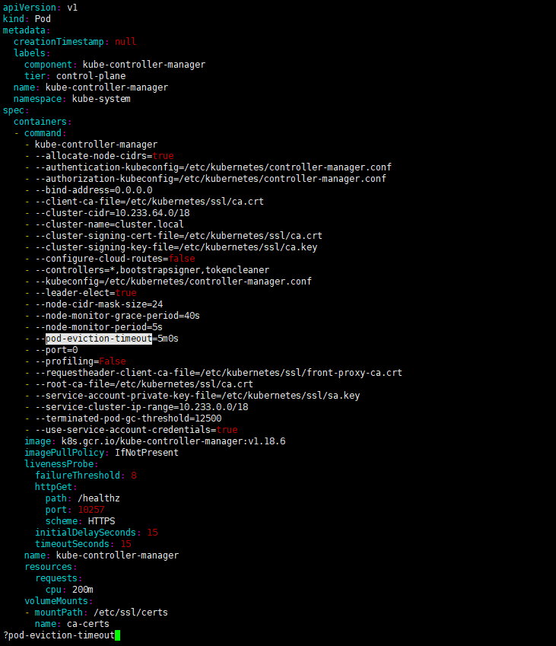

1. 扩容node08，受影响服务

|  |
| --- |
| airflow |
| cmhk-benovelty-admin-portal |
| gitlab |
| harbor |
| jhub |
| minio |
| prometheus |

node09，受影响服务

|  |
| --- |
| cmhk-benovelty-portal-api |
| gitlab |
| harbor |
| istio-system |
| jenkins |
| jhub |
| kibana |
| longhorn-system |
| metallb-system |
| prometheus |

Node10, 受影响服务

|  |
| --- |
| airflow |
| ambassador |
| gitlab |
| harbor |
| jhub |
| longhorn-system |
| metallb-system |
| minio |
| redis |

Node11，受影响服务

|  |
| --- |
| airflow |
| ambassador |
| gitlab |
| harbor |
| jhub |
| longhorn-system |
| metallb-system |
| mongodb |
| rbd-provisioner |



参考资料：

Pod 迁移 & Node 重启

<https://blog.fatedier.com/2020/07/22/k8s-pod-directional-migration/>

<https://blog.csdn.net/yanggd1987/article/details/108139436>

https://www.jianshu.com/p/eb5589b7449b